

**RESEARCH METHODOLOGIES AND EMERGING TECHNOLOGIES**

**(CIS013-3/CIS017-3)**

Contextual Report

**MOBILE application to improve mental health of persons with Dementia**

BSc (Hons) Computer Science & Software Engineering

University of Bedfordshire

Nishshanka Nimesh Mendis

2012430

# Abstract

In this report the researcher going to explain about the Introduction to the project. This section will contain background details of the project, aim and objectives and description of the artefact. Second chapter is the Literature Review with the market research and similar system review which is explain how to assist a person with Dementia with a mobile application, further detailed information is in the appendices at end of this report. Third chapter is the Project plan which researcher going to discuss about the plans and how it is going to implement in each period using a Gannt chart. Final chapter is the Planning of the artefact discussing about the plan of the application which is outcome of this research.

Contents

Abstract ii

List of figures iv

List of tables v

1. Introduction 1

1.1 – Background of the project 1

1.2 – Aims and Objectives 1

1.3 – Description of the artefact 2

2. Literature Review/Market Survey 3

2.1 – Literature Review 3

2.1.1 – Introduction 3

2.1.2 – Recovery memory using Mobile Application 5

2.1.3 – Existing Health care Application for Dementia 6

2.1.4 – Conclusion 10

2.2 – Market Research 11

3. Project Plan 16

3.1 – Introduction 16

3.2 – Gantt Chart 16

4. Planning of the Artefact 17

4.1 – Project planning 17

4.2 – Design and Development 17

4.3 – Testing 17

4.4 – Evaluation 17

References 18

Appendix 20

Appendix A 20

Appendix B 20

Appendix C 21

Appendix D 22

Appendix E 23

Appendix F 24

Appendix G 24

Appendix H 25

Appendix I 25

Appendix J 26

Appendix K 26

Appendix L 26

Appendix M 27

# List of figures

Figure 1 - Doctors' questionnaire form screenshot 1 16

Figure 2 - Doctors' questionnaire form screenshot 2 17

Figure 3 - Doctors' questionnaire form screenshot 3 17

Figure 4 - Pie chart of survey Question one 18

Figure 5 - Pie chart of survey Question two 18

Figure 6 - Pie chart of survey Question three 18

Figure 7 - Bar chart of survey Question four 19

Figure 8 - Pie chart of survey Question five 19

Figure 9 - Pie chart of survey Question six 19

Figure 10 - Pie chart of survey Question seven 20

Figure 11 - Bar chart of survey Question eight 20

Figure 12 - Bar chart of survey Question nine 20

Figure 13 - Gannt chart 21

# List of tables

Table 1 - Frequency table for the survey Question one 18

Table 2 - Frequency table for the survey Question two 18

Table 3 - Frequency table for the survey Question three 18

Table 4 - Frequency table for the survey Question four 19

Table 5 - Frequency table for the survey Question five 19

Table 6 - Frequency table for the survey Question six 19

Table 7 - Frequency table for the survey Question seven 20

Table 8 - Frequency table for the survey Question eight 20

Table 9 - Frequency table for the survey Question nine 20

# Introduction

## 1.1 – Background of the project

The proposed project is to develop a mobile application for people with Dementia and Alzheimer's. Dementia is recognized as one of the growing social health problems among older people in society. This is not a problem for the individual concerned, but it causes stress to the family members, neighbours, friends, and others who are involved in supporting a person with Dementia. Dementia is caused by abnormal brain changes, damage to or loss of never cells and their connection in the brain and communication problems, a change in personality, and a reduce ability to carry out daily activities such as washing or dressing. Depending on the area of the brain that is affected, they may face experiences in short term or long-term memory loss. It may lead to physical malfunctioning and disability too. Simply the drugs do not use for these people to improve their mental stability but if the patient is risk of harming themselves or others, they must seek medical attention to take drugs. Otherwise, doctors recommending for music sessions and sound therapies.

Since this is a modern era there is a strong relationship between human and information & communication technology. By using information technology, it can develop solution applications. This proposed project will help people with dementia maintain and improve mental functions. Since persons with Dementia have difficulties in concentrating, their span of attention is low, and they project irregular behaviours. Due to this reason, the caretakers find it difficult to handle them. Here the researcher can build their attention through calm sounds such as water flowing, the sound of birds, playing soothing music to calm them down, and have a conversation about that sound and what they heard. From the beginning by studying the patient’s behaviour and output, the researcher can get to know his or her likes, dislikes and interest to develop a successful application to improve their concentration and span of attention. For that, the researcher needs to provide activities to remember things, ask questions about their past and what they remember without giving any sort of pressure or stress to the patient. By using attractive colours to the user interface, the system can draw the patient’s attention to the device.

## 1.2 – Aims and Objectives

**Aims**

* To Develop a mobile application to improve mental health and quality of life a person with Dementia.

**Objectives**

* To Identify the patient’s attributes properly relating to Demetria which is suitable to the patient.
* To implement a neural network which predict the range possibility of Dementia level.
* To develop a mobile application to map simple tasks to complete to get the attention of the patient.
* To evaluate the proposed system with current mental health application

## 1.3 – Description of the artefact

The proposed system is an application helps for the people with Dementia to increase their thinking ability and recognizing or remembering any object.

**Features of the system,**

* User registration

Before using application, user needs to make a profile by entering personal data such as age, description of medical condition and other than the user’s identity information.

* Displaying user details

In here, user needs to see their user details such as their personal photo, name, age, and other details of them.

* Recognizing objects

After successful login proposed application provides simple activities or tasks such as recognizing objects such as shapes, colour of some object and size of any object. This is helpful to improve user’s logical side of thinking.

* Memory recall

Further user can face activities such as remembering simple words and repeat asking the word after few minutes. This will help to find out their memory with their responses.

* Music

Most therapists follow this step to calm down the patients. Sometimes this helpful to gaining memory, some incident happened to their lives. The system can have ability to recall their memory from that.

* Soothing sounds

The researcher’s main target is to keep the patient calm without give any pressure to their minds. Because of their mental stability they might cannot here sounds which disturbing to them. In this part mainly consider about what they here. Sounds such as sound of birds, sound of water droplets or water flowing and other non-disturbing sounds.

* Games

This feature helpful to the users to improve the logical thinking and improve memory to user to take decisions.

# Literature Review/Market Survey

A proper literature review linked to mental health of people with Dementia, the impact of it for the society and to individuals and the solutions given so far will be provided in this section. The importance and the reasons for the researcher to undertake the research will be highlighted in this section. Then the researcher liked to discuss how the Information technology based mobile application will affect to persons with Dementia.

## 2.1 – Literature Review

### 2.1.1 – Introduction

All the areas required for the research of this proposed topic is covered in this literature review. What is Dementia, what causes of Dementia, impact of people with Dementia, what are the medical treatment that doctors’ preferring and how mobile application is helpful to recover their memory for it is discussed under this chapter Market research was carried out in the aid of pointing out the importance of this research. The latter part of this literature review concentrates on the similar systems which are critically evaluated. For the similar systems researcher decided to choose Android and iOS applications which most users are using these two operating systems around the world.

#### 2.1.1.1 – What is Dementia?

Dementia is a loss of mental functions that is severe enough to affect your daily activities or routines and functions such as memory, language skills, visual recognition, problem solving, trouble with everyday tasks, ability to focus and pay attention *(U.S. National Library of Medicine, 2020).* The researcher explains more information under Appendix A.

There are several common types of Dementia which is explains more information under Appendix B and the factors which cause of the Dementia is given in Appendix C.

Generally, dementia experiences these stages. However, it might fluctuate contingent upon the region of the cerebrum that is influenced. The researcher explained stages under the Appendix D.

#### 2.1.1.2 – Impact of people with Dementia

The researcher explains further details under Impact of people with Dementia is discussed under Appendix E.

#### 2.1.1.3 – Counselling and Therapy

Persons with Dementia is main thing is to follow counselling a doctor to seeking advices. Counselling and therapies are discussed under Appendix F.

#### 2.1.1.4 – Relaxation and Recovery methods

In this section researcher discussed about the relaxation methods which relevant to persons with Dementia. The researcher explains relaxation and recovery methods under Appendix G. According to the research there are two main therapies which is approved by doctors. One recovery method is music therapy. The researcher discussed about music therapy under Appendix H. Another method to recover is brain exercises which doctors are following to recover memory of persons with Dementia. Further details discussed under the Appendix I.

### 2.1.2 – Recovery memory using Mobile Application

#### 2.1.2.1 – Introduction and Background

Versatile applications are programming programs living on a compact gadget, for example, a cell phone, watch, or tablet. Favourable circumstances of application innovation for treatment conveyance incorporate its straightforward entry to data, the capacity to convey home practice activities, for example, sound chronicles, capacity to send notices and updates, and potential to catch dynamic and aloof use criticism. Applications may house data accessible for disconnected use, interface with sites, or both. Applications with data accessible disconnected might be obviously appropriate for the conveyance of treatments that give standard home practice practices so parental figures do not have to associate with the web each time they wish to utilize them *(Sikder, A.T., Yang, F.C., Schafer, R., Dowling, G.A., Traeger, L. and Jain, F.A., 2019)*.

The utilization of the Internet is quickly expanding around the world, including among more seasoned grown-ups, and can possibly be a powerful method of conveying mediations to help family guardians of individuals with dementia all through the providing care measure *(Boots LMM, de Vugt ME, van Knippenberg RJM, 2014)*. A few ongoing meta-examinations of Randomized Controlled Trials (RCTs) on Internet mediations for more youthful objective gatherings with side effects of gloom or tension have indicated that these intercessions can possibly be (cost)effective *(Hedman E, Andersson E, Lindefors N, Andersson G, Rück C et al, 2012)*. From the purpose of view of family guardians themselves, Internet backing may have some preferences contrasted with vis-à-vis uphold. Individuals can partake in a web course at the time that is generally appropriate for them; they do not have to head bent a medical aid proficient, which spares time; and Internet backing can be simpler for them to acknowledge see able of the shame related with searching for help from an expert (emotional wellness) care supplier *(Blom MM, Bosman JE, Cuijpers P, Zarit SH, Pot AM, 2013)*. Be that as it may, until now, results from RCTs on Internet mediations to decrease the mental manifestations of guardians of individuals with dementia are still scant *(Boots LMM, de Vugt ME, van Knippenberg RJM, 2014)*.

In this unique situation, the help of innovation offers a lot of potentials and can improve the personal satisfaction of individuals with dementia and their casual guardians *(B. C. Zapata, J. L. Fernández-Alemán, A. Idri, and A. Toval, 2015)*. Late activities in smart gadgets (i.e., smartphones, versatile workstations, tablets, and so on) have made portable applications a promising hotspot for connecting with individuals in medical services *(K. Yousaf, Z. Mehmood, T. Saba et al, 2018)*, especially persons with disabilities with high medical service’s needs *(B. Klimova, 2017)*. Researchers demonstrated that persons with disabilities can utilize touchscreen gadgets effectively, and this innovation can give a wide scope of advantages to them and their guardians. It makes a significant open door for engineers to convey an important application by adding drawing in exercises for such individuals to carry on with their life more autonomously *(D. Hitch, J. Swan, R. Pattison, and R. Stefaniak, 2017)*.

### 2.1.3 – Existing Health care Application for Dementia

#### 2.1.3.1 – Introduction

Smartphones advancements are ideal for medical services intercessions since they incorporate various capacities, for example, Internet access, portable media transmission, sensors, warnings, and the capacity to introduce applications that are clinically engaged *(Putzer, 2012)*. Indeed, versatile innovations have been demonstrated to be a viable way to deal with wellbeing observing for grown-ups with changing ongoing ailments *(Hardinge et al, 2015)*. the survey additionally revealed that advanced mobile phone applications have been appeared to help persistent consideration in psychological wellness settings for conditions including psychosis/schizophrenia, despondency, bipolar confusion, and substance misuse. Such innovations have demonstrated adequacy in checking tolerant symptomology, encouraging patient self-administration, screening patients for melancholy, and giving a subordinate to talk treatment. Cell phones likewise have shown to be possibly helpful for evaluating psychological capacity in more established grown-ups *(Ellen Leslie Brown, Nicole Ruggiano, Juanjuan Li, 2017)* also, conveying customized memory treatment *(Zhang & Ho, 2017)* and, the early examination is as of now looking at the utilization of cell phone innovations for correspondence treatment in people with neurological issues *(Ireland et al, 2016)* and to assist with security observing for more seasoned grown-ups *(Sun et al, 2014)*.

Under given existing Android an iOS applications, the researcher personally downloaded from Google Play Store and iOS App Store and the researcher got user experience from each application and plan to discussed pros and cons as a summary under the conclusion section final part of this literature review.

#### 2.1.3.2 – Android based Applications

The researcher decided to select and discussed about similar systems to which has highest user reviews on Google Play store.

##### 2.1.3.2.1 – Cognicare – Support for Dementia Care

Cognicare is a mobile application which was developed by **CogniHealth Ltd** falls under **Health and Fitness** category. This application is a personal guide mobile application targeted for the family, friends and care takers looking after people with Dementia. Application provides feature called Project Soothe which was initiative by the **University of Edinburgh** user can enjoy a collection of soothing images to improve mood and wellbeing. Application provide image collections of nature inspired by themes such as sky, water, landscape, and animals fall under to this.

Initially user needs to create a user account or user needs to sign with their Google Account. After creating an account user needs to provide information about persons with Dementia. After successfully creating the profile user can access features as follows,

These features have been explained under Appendix J.

Further system provides user to create music play list. In here system give users guidance to how to create a suitable playlist. Cognicare also provide users to share their personal experience, their knowledge, and their good practices with each other in this application.

##### 2.1.3.2.2 – Dementia Guide Expert

Dementia Guide Expert is a mobile application which was developed by **University of Illinois** falls under **Education** category. This application is a personal guide mobile application targeted for the family, friends and care takers looking after people with Dementia. This system does not contain support functions relating to the persons with Dementia. System provides lot of information and guidelines such as diagnosis and treatment, how to live with persons with Dementia with references and citations.

##### 2.1.3.2.3 – A Walk Through Dementia

A Walk-Through Dementia is a mobile application which was developed by **Alzheimer’s Research UK** falls under **Health and Fitness** category. This application brings out Virtual Reality experience to the user. *‘Challenge we have got as a charity of trying to communicate the reality of what Dementia is like for people using virtual reality is uniquely powerful way of doing that’ (Tim Parry, Alzheimer’s Research UK, 2016)*. Further Tim Parry (2016) explain this project trying to simulate in a way some of other symptoms that people with Dementia experience beyond memory loss, lots of the kind of issues that people with dementia face on a day-to-day basis that many people might not realize.

Another objective of this project was trying to recreate what persons with dementia see and how they feel and then trying to get that filling across to the people who are, and care takers need to look after them and help them to understand how persons with Dementia feel, Care takers can help them in that process.

##### 2.1.3.2.4 – Dementia Stages Ability Model – Teepa Snow’s GEMS

Dementia stages ability model is an Android mobile application which was developed by **Teepa Snow’s Positive Approach to care** falls under **Education** category. *‘Much the same as pearls, every individual is valuable, important, and special, and given the correct setting and care, can sparkle’ (Teepa Snow)*. Teepa Snow created this GEMS model based on Allen Cognitive scale, recognize the shifts in skills and abilities in any given moment. With dementia, while the movement, pattern, and changes may appear to be exceptionally unique for each kind of dementia, the development through the GEMS is to some degree unsurprising.

This system will help get familiar with the attributes of every GEMS state and approaches to give the ideal consideration to that state. The application incorporates a dementia scale correlation diagram, video clasps of Teepa Snow clarifying every GEMS state, and video and photographs portraying our Hand-under-Hand method to guide and help with regular assignments.

##### 2.1.3.2.5 – RecoverBrain Therapy for Aphasia, Stroke, Dementia

RecoverBrain Therapy is an Android based mobile application which was developed by **ImagiRation LLC** falls under **Medical** category. This application system provides user to test their brain activities by providing small activities such as pick and drop to correct place, select similar objects, and select sizes. This application has three main difficulties levels. System provides facility to user to choose any level they like among three Difficult, Intermediary and Easy these options. System provides games in each section. User can play a game level and go to next level and complete the whole level after that. Additionally, system provides marking points to appreciate the user by giving a small award of appreciations. This system available sounds which is soothes to persons with Dementia and it does not contain sounds which disturbs the person with Dementia. This system completely kid-friendly application, even little children also can enjoy this application.

System provides user to check their statistics using progress chart, in here user can check daily weekly, monthly and yearly statistics.

##### 2.1.3.2.6 – Memory Exercise for Alzheimer’s

Memory Exercise for Alzheimer’s is a mobile application which was developed by **Furkan Torun** falls under **Health and Fitness** category. Developer’s main objective is to improve memory for persons with Dementia and persons with Alzheimer’s. This system is a memory exercise game which develops the persons memory. Developers specially mentioned this application for elder people.

This application is about to select true or false of given random colour from the system in given period of seconds. If the time ran out game is over. Game is over once he gives the incorrect answer. User needs to concentrate to the colour an give the correct answer to break the fastest period.

Using this application user can improve their memory power as well as to improve their thinking ability. User needs to have high concentration to this game to win high scores.

#### 2.1.3.3 – iOS-based Applications

The researcher decided to select and discussed about similar systems to which has highest user reviews on Apple App store.

##### 2.1.3.3.1 – Dementia Test – Risk calculator of Dementia

Dementia Test is an iOS based mobile application which was developed by **Pears Health Cyber** falls under **Medical** category. This application is a complex and precise risk calculator for detecting Dementia. This system using combination of multiple test algorithms, Application developers developed this test which considering wide range of factors which can recognize smaller nuances than any other risk calculator. System provides user to complete their questionnaire, after completing system calculates the potential risk of developing dementia in person with Dementia.

This application further offers following functionalities to the users: Refer Appendix K.

##### 2.1.3.3.2 – MindMate – For a healthy brain

MindMate is an iOS based mobile application which was developed by **MindMate LTD** falls under **Health and Fitness** category. This system transforms and maintains health and wellness daily workouts and mental activities. Features provided by the MindMate application: These features discussed under Appendix L.

##### 2.1.3.3.3 – Alzheimer’s Disease Pocketcard

Alzheimer’s Disease Pocketcard is an iOS based mobile application which was developed by **Börm Bruckmeier Publishing LLC** falls under **Medical** category. This application helps physicians, other health care professionals care and care givers for patients with Alzheimer’s disease at the point of care. This application features clinically relevant information on Alzheimer’s and interactive tools to help users efficiently assess persons with Dementia and interview their care givers. This application provides following features to the user: Features discussed under the Appendix M.

##### 2.1.3.3.4 – Brain Yoga Brain Training Game

Brain Yoga Brain Training Game is an iOS-based application which was developed by **Sarah Pierce** falls under **Games** category. This application provides Eleven puzzle games to train memory, vocabulary, numeracy, spatial ability, and pattern matching of persons with Dementia.

Their objective to provide users to do puzzle games without a timer pressure or high score. Their main target is to reduce the mental stress of person with Dementia. These eleven puzzle types have ten difficulty levels from beginner to advanced. Relaxing background music is playing to help to get the focus of the person with Dementia.

### 2.1.4 – Conclusion

Since Dementia is a common problem in the society, most developers tried to provide kind of solutions for the problem to control it. According to researcher’s user experience of both Android and iOS mobile applications have proper functions and used algorithms to come up with conclusions and solutions to the users and for the persons with Dementia and provide user a better service from their application. Application such as *(Dementia Guide Expert, 2018), (Cognicare - Support For Dementia Care, 2017), (Dementia Stages Ability Model- Teepa Snow’S GEMS, 2020), (Alzheimer’S Disease Pocketcard, 2013),* provides knowledge, share experience, guidance, and health tips. Applications such as *(RecoverBrain Therapy for Aphasia, Stroke, Dementia, 2018), (Memory Exercise for Alzheimers, 2019),* mainly focus about to reduce the mental stress, get the attention, make the user’s focus to a task or activity to do, providing music and entertaining them, and to improve thinking ability and to improve their brain processing power by problem solving. Some mobile applications provide users to play games. Applications such as *(A Walk Through Dementia, 2017), (Dementia Test - risk calculator of dementia, 2015),* provides unique experience of using Virtual Reality technology and using algorithms to provide user decisions.

All these existing applications which are mentioned existing similar mobile applications reviewed by the researcher. All these existing applications have unique features on their own. Since all the applications explained under similar systems are user-friendly applications, these similar review applications do have pros and cons in those applications. Application such as *(Memory Exercise for Alzheimers, 2019)*, *(Dementia Guide Expert, 2018),* developers did not care about the background of the application which is one of the main factors to user to draw their attention to the application. Using colours is important thing in here. Application such as *(Dementia Guide Expert, 2018),* provided only valuable information to the user no other functions available in the application.

Since all features that researcher has been mentioned above under Aims and Objectives going to be integrated in the proposed system. Researcher hopes this system will be helpful to the users. Since problem with Dementia is one of the main threats to society and the proposed system will bring positive results.

## 2.2 – Market Research

A market research was conducted by the researcher to further study on the importance of proposed research and the situation of the Dementia and how it impacts to the current society. The researcher conducted two questionnaires which one questionnaire was given to the Doctors and other questionnaire was given to the care takers and family members of the patients with Dementia. Simultaneously, the researcher carried out an in-person interview with a doctor.

Unfortunately, due to Covid-19 situation the researcher got less responds rate from the doctors’ questionnaire in given period as planned in Gantt chart. As backup option the researcher conduct another questionnaire to the family members of the patients with Dementia regarding the proposed application. The researcher’s in-person interview the researcher asked the same questions which were given in doctors’ questionnaire. Here are the screen shots images of doctors’ questionnaire given below.

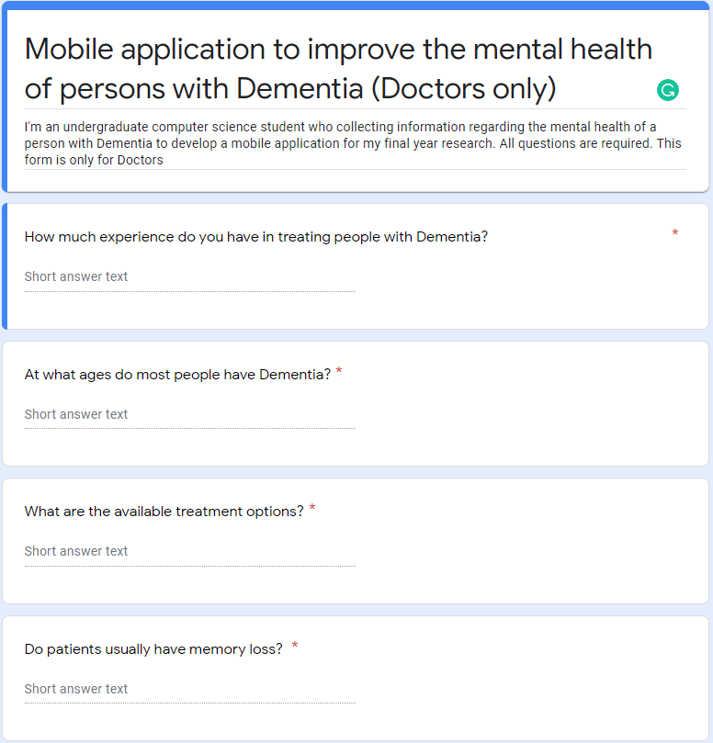

Figure 1 - Doctors' questionnaire form screenshot 1

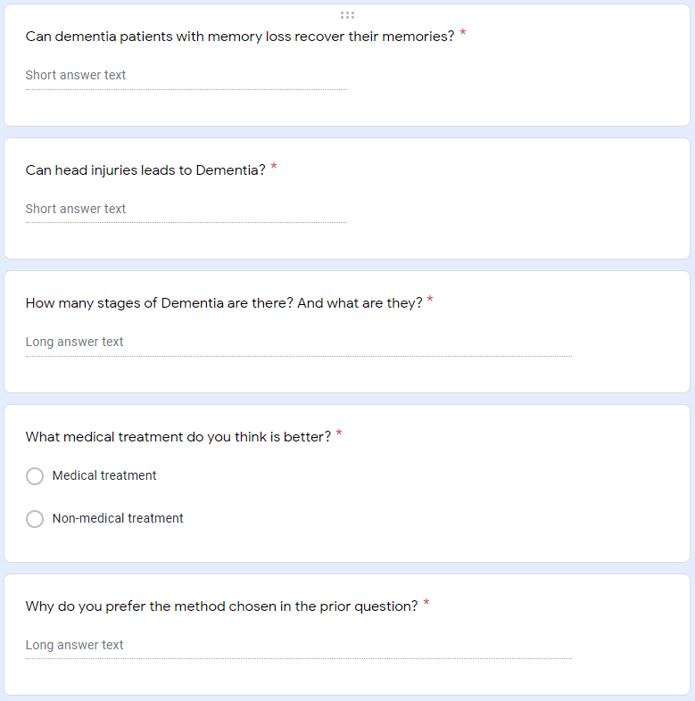

Figure 2 - Doctors' questionnaire form screenshot 2

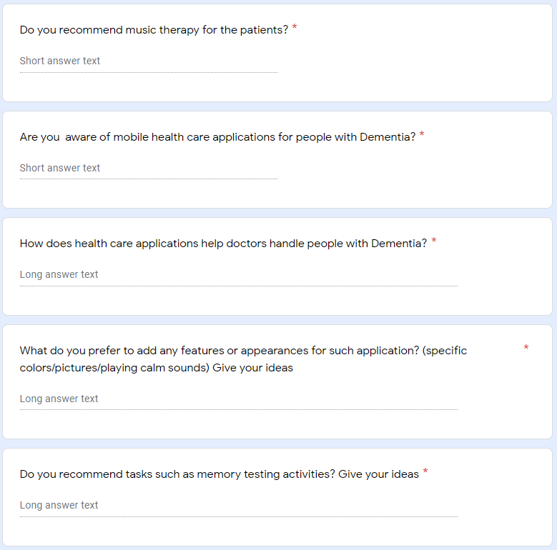

Figure 3 - Doctors' questionnaire form screenshot 3

Since the researcher received less responses in given period, the researcher took ideas from the responses to develop the application. Further the researcher conducted another feedback collection from sample populations who are care takers and family members of persons of Dementia selected from whole population. A survey of selected questionnaire was passed on to 40 people to gather the data. The researcher used Google forms to collect data. Then the gathered data was analysed using IBM SPSS Statics software.

The researcher’s first survey was to find the age limits of the among individuals. Majority of individuals are above 75 years old. Then the individuals are between 60 – 70 years old. The researcher has concluded that most people with Dementia are from elder generation.

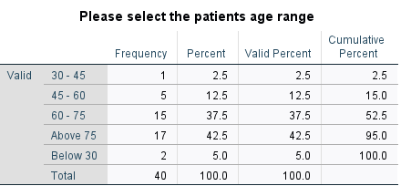

Table 1 - Frequency table for the survey Question one

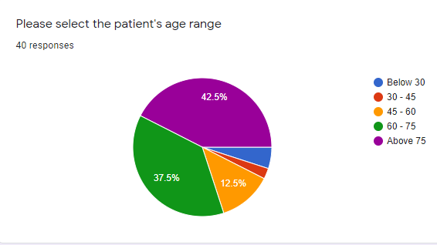

Figure 4 - Pie chart of survey Question one

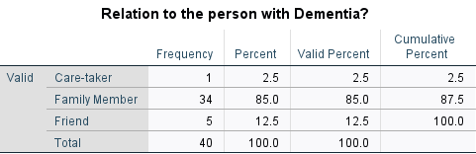

Table 2 - Frequency table for the survey Question two

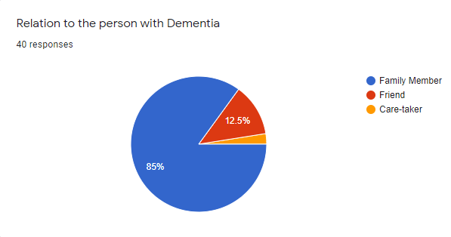

Figure 5 - Pie chart of survey Question two

Next the survey was focused on how long patient has been affected by the Dementia. Among the 40 individuals nearly 50% are more than 5 years.

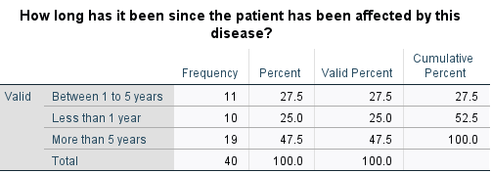

Table 3 - Frequency table for the survey Question three

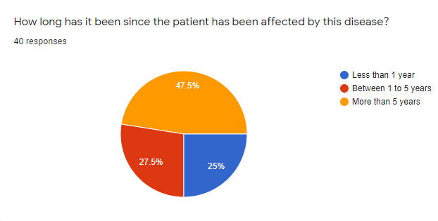

Figure 6 - Pie chart of survey Question three

Next survey was focused about the symptoms showed by the patient. More than 70% of individuals has short term memory losses and equal percentage of 57.5% individual’s loss of ability to do daily tasks and personality and behaviour changes.

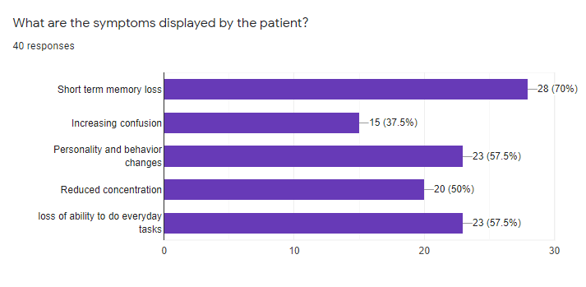

Figure 7 - Bar chart of survey Question four

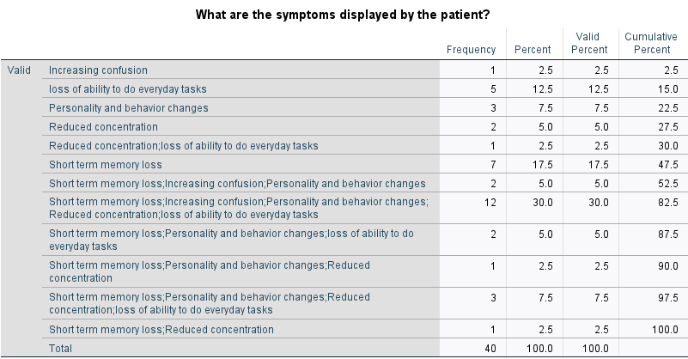

Table 4 - Frequency table for the survey Question four

Among the 40 individuals more than 60% of people have no prior experience with a person with Dementia.

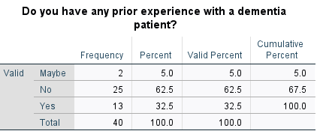

Table 5 - Frequency table for the survey Question five

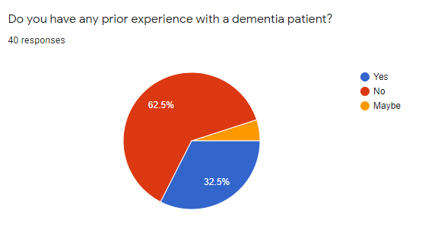

Figure 8 - Pie chart of survey Question five

Next survey was focused on that individuals have mobile phones. Almost everyone has mobile phones on their own.

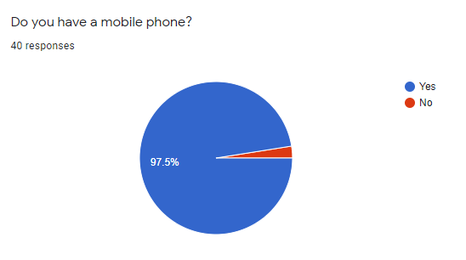

Figure 9 - Pie chart of survey Question six

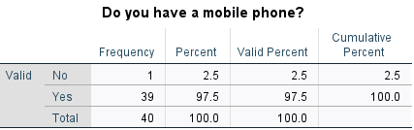

Table 6 - Frequency table for the survey Question six

The researcher’s next survey about individuals do aware of any mobile application to assist in improvement of the mental health of a person with Dementia. More than 60% of individuals does not aware of health care applications available in application store.

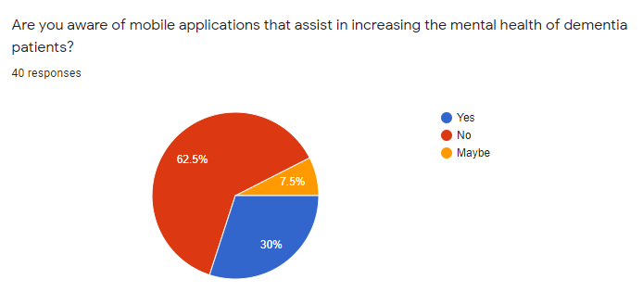

Figure 10 - Pie chart of survey Question seven

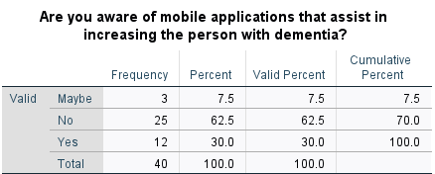

Table 7 - Frequency table for the survey Question seven

Next survey about what recommended activities by doctors for persons with Dementia. More than 60% recommending music therapies and brain exercises for the people with Dementia.

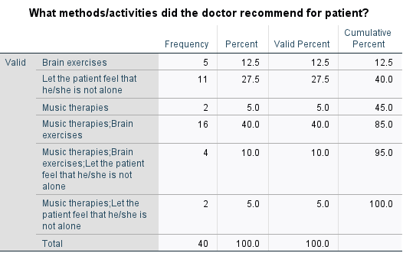

Table 8 - Frequency table for the survey Question eight

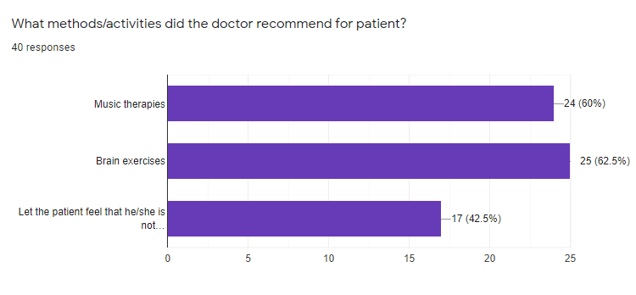

Figure 11 - Bar chart of survey Question eight

Next survey about what users expecting recommended features from a mobile application to assist a person with Dementia. 65% individual’s choice was brain exercise games from the application. More than 60% decided to have music therapy in the application.

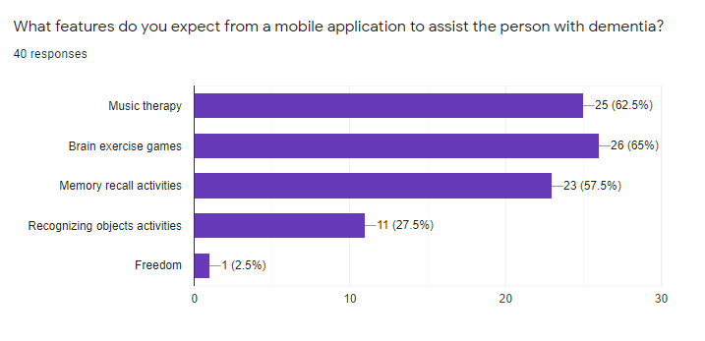

Figure 12 - Bar chart of survey Question nine

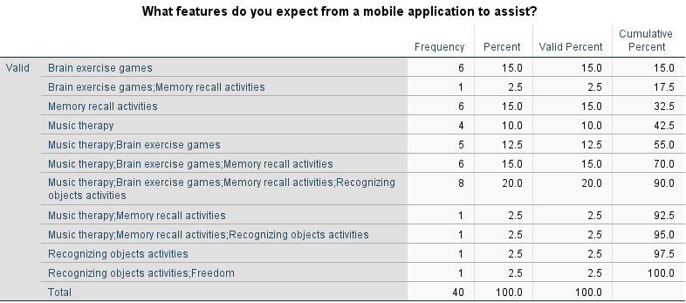

Table 9 - Frequency table for the survey Question nine

# Project Plan

## 3.1 – Introduction

Main task of the proposed project is to develop a mobile application for persons with Dementia. Agile methodology is used for the implementation of the proposed system. Development phase is divided into several sprints for system functions. Functions of the system will be separately implemented in these sprints. After every sprint, sprint tests will be carried out.

## 3.2 – Gantt Chart

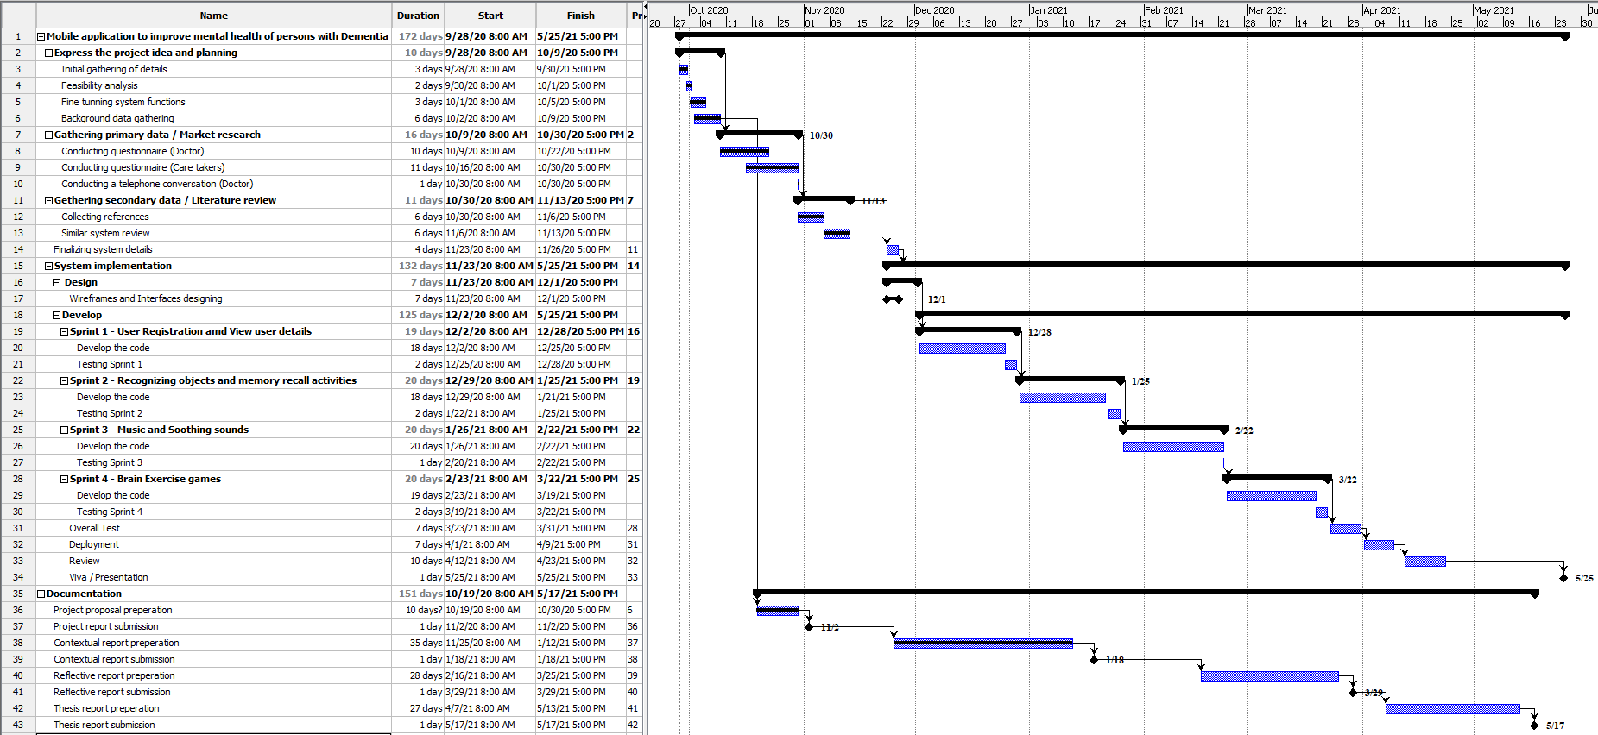

Figure 13 - Gannt chart

The researcher has completed the market research, literature review and the feasibility analysis. The researcher done up to contextual report and two main documents has been completed according to the time duration allocated. The researcher needs to start wireframe and interface designing.

# Planning of the Artefact

## 4.1 – Project planning

The proposed system was planned to be developed as a mobile application for persons with Dementia. Proposed system is using agile model where Requirements were gathered by literature review and the market research. The researcher used two Google forms to collect primary data from Doctors and another form to care-takers, family members of person with Dementia and IBM SPSS was used to analyse the primary data. The researcher also conducted an interview with a doctor to collect information regarding the Dementia and applications related to Dementia. Secondary data was gathered from Google Scholar collection source of journals, books, and other educational materials. All these tasks were planned under a time frame with milestones, Gantt chart included all the tasks and time periods which relevant to the task.

## 4.2 – Design and Development

As an outcome of this research is a mobile application which is going to develop by Android Studio which is an open source own by Google. The researcher using his own personal laptop as the hardware device All the required functions developed by Java programming language and algorithms are going to develop by Python language. Since the researcher using agile model, the researcher going to use four sprints under development part. After developing each function, functions will be carried out to test the application. Further sprint wise testing will also be performed. The researcher going to use Appium to test the sprints in the application. The researcher is using firebase as the database facility which provides by the Google.

## 4.3 – Testing

After developing each function, functions will be carried out to test the application. Further sprint wise testing will also be performed. The researcher going to using Appium application to test the overall functionalities. After completing the application overall testing is carried out once again to identify whether the application working correctly without bugs and errors.

## 4.4 – Evaluation

Finally, the researcher going to release the application prototype to the users who need this application. The researcher let random 10 persons with Dementia to have a user experience and the researcher going to give another google form which regarding the research application and get their ideas.

# References

Anderson, J.G., Rose, K.M. and Taylor, A.G., 2016. A descriptive study of the nutrition-related concerns of caregivers of persons with dementia. Journal of Aging Research and Clinical Practice, 5(1), pp.1-6.

Bateman, D.R., Srinivas, B., Emmett, T.W., Schleyer, T.K., Holden, R.J., Hendrie, H.C. and Callahan, C.M., 2017. Categorizing health outcomes and efficacy of mHealth apps for persons with cognitive impairment: a systematic review. Journal of medical Internet research, 19(8), p.e301.

Blom, M.M., Zarit, S.H., Zwaaftink, R.B.G., Cuijpers, P. and Pot, A.M., 2015. Effectiveness of an Internet intervention for family caregivers of people with dementia: results of a randomized controlled trial. PloS one, 10(2), p.e0116622.

Brooke, J., 2016. Caring for patients with dementia. *Nursing in Practice*, *89*, pp.68-71.

Davis, B., Nies, M., Shehab, M., Shenk, D. and Alfonzo, P., 2014. Developing a pilot e-mobile app for dementia caregiver support: Lessons learned. Online Journal of Nursing Informatics (OJNI), 18(1).

Grossman, M.R., Zak, D.K. and Zelinski, E.M., 2018. Mobile apps for caregivers of older adults: Quantitative content analysis. JMIR mHealth and uHealth, 6(7), p.e162.

Guo, Y., Yang, F., Hu, F., Li, W., Ruggiano, N. and Lee, H.Y., 2020. Existing Mobile Phone Apps for Self-Care Management of People With Alzheimer Disease and Related Dementias: Systematic Analysis. JMIR aging, 3(1), p.e15290.

Halbach, T., Solheim, I., Ytrehus, S. and Schulz, T., 2018. A Mobile application for supporting dementia relatives: a case study. Studies in health technology and informatics, 256, pp.839-846.

Imtiaz, D., Khan, A. and Seelye, A., 2018. A mobile multimedia reminiscence therapy application to reduce behavioral and psychological symptoms in persons with Alzheimer’s. Journal of healthcare engineering, 2018.

Kabir, Z.N., Leung, A.Y.M., Grundberg, Å., Boström, A.M., Lämås, K., Kallström, A.P., Moberg, C., Cronfalk, B.S., Meijer, S. and Konradsen, H., 2020. Care of family caregivers of persons with dementia (CaFCa) through a tailor-made mobile app: study protocol of a complex intervention study. BMC geriatrics, 20(1), pp.1-7.

Kernebeck, S., Holle, D., Pogscheba, P., Jordan, F., Mertl, F., Huldtgren, A., Bader, S., Kirste, T., Teipel, S., Holle, B. and Halek, M., 2019. A tablet app–and sensor-based assistive technology intervention for informal caregivers to manage the challenging behavior of people with dementia (the insideDEM study): protocol for a feasibility study. JMIR research protocols, 8(2), p.e11630.

Klimova, B., 2017. Mobile phone apps in the management and assessment of mild cognitive impairment and/or mild-to-moderate dementia: an opinion article on recent findings. Frontiers in human neuroscience, 11, p.461.

Lancioni, G.E., Singh, N.N., O’Reilly, M.F., Sigafoos, J., D’Amico, F., Turnone, B., Laporta, D., Scordamaglia, A. and Pinto, K., 2019. Smartphone-based interventions to foster simple activity and personal satisfaction in people with advanced Alzheimer’s disease. American Journal of Alzheimer's Disease & Other Dementias®, 34(7-8), pp.478-485.

Moussa, Y., Mahdanian, A.A., Yu, C., Segal, M., Looper, K.J., Vahia, I.V. and Rej, S., 2017. Mobile health technology in late-life mental illness: a focused literature review. The American Journal of Geriatric Psychiatry, 25(8), pp.865-872.

National Collaborating Centre for Mental Health (UK, 2007. Dementia. In Dementia: A NICE-SCIE Guideline on Supporting People With Dementia and Their Carers in Health and Social Care. British Psychological Society.

O'Connor, E., Farrow, M. and Hatherly, C., 2014. Randomized comparison of mobile and web-tools to provide dementia risk reduction education: use, engagement and participant satisfaction. JMIR Mental Health, 1(1), p.e4.

Rathnayake, S., 2019. Co-design of an mHealth application for family carers of people with dementia to address needs related to the functional disability of their care recipients.

Rathnayake, S., Moyle, W., Jones, C.J. and Calleja, P., 2019. Development of an mHealth application for family carers of people with dementia: A study protocol. Collegian, 26(2), pp.295-301.

Reyes, A.K., Camargo, J.E. and Díaz, G.M., 2015, November. Design of a mobile application to support non-pharmacological therapies for people with alzheimer disease. In ICSH (pp. 321-332). Springer, Cham.

Sikder, A.T., Yang, F.C., Schafer, R., Dowling, G.A., Traeger, L. and Jain, F.A., 2019. Mentalizing imagery therapy mobile app to enhance the mood of family dementia caregivers: feasibility and limited efficacy testing. JMIR aging, 2(1), p.e12850.

Sindi, S., Calov, E., Fokkens, J., Ngandu, T., Soininen, H., Tuomilehto, J. and Kivipelto, M., 2015. The CAIDE Dementia Risk Score App: The development of an evidence‐based mobile application to predict the risk of dementia. Alzheimer's & Dementia: Diagnosis, Assessment & Disease Monitoring, 1(3), pp.328-333.

Vuong, N.K., Goh, S.G.A., Chan, S. and Lau, C.T., 2013, July. A mobile-health application to detect wandering patterns of elderly people in home environment. In 2013 35th Annual International Conference of the IEEE Engineering in Medicine and Biology Society (EMBC) (pp. 6748-6751). IEEE.

WebMD. 2020. What Is Dementia?. [online] Available at: <https://www.webmd.com/alzheimers/types-dementia#1> [Accessed 3 December 2020].

Yousaf, K., Mehmood, Z., Saba, T., Rehman, A., Munshi, A.M., Alharbey, R. and Rashid, M., 2019. Mobile-health applications for the efficient delivery of health care facility to people with dementia (PwD) and support to their carers: a survey. BioMed research international, 2019.

Zwingmann, I., Michalowsky, B., Esser, A., Kaczynski, A., Monsees, J., Keller, A., Hertel, J., Wucherer, D., Thyrian, J.R., Eichler, T. and Kilimann, I., 2019. Identifying unmet needs of family dementia caregivers: results of the baseline assessment of a cluster-randomized controlled intervention trial. Journal of Alzheimer's Disease, 67(2), pp.527-539.

# Appendix

## Appendix A

*‘A disorder because of illness of the cerebrum, as a rule of a persistent or reformist nature, where there is the unsettling influence of different higher cortical capacities, including memory, thinking, direction, cognizance, figuring, learning ability, language, and judgment. Awareness is not impeded. Weaknesses of intellectual capacity ordinarily go with, periodically went before, by weakening in enthusiastic control, social conduct, or inspiration. The disorder happens in Alzheimer's infection, in cerebrovascular sickness, and in different conditions basically or optionally influencing the mind’ (National Collaborating Centre for Mental Health UK, 2007).*

Dementia results from an assortment of illnesses and wounds that essentially or optionally influence the mind, for example, Alzheimer's sickness or stroke *(World Health Organization, 2012).* Dementia is one of the significant reasons for incapacity and reliance among more seasoned individuals around the world. It tends to be overpowering, for the individuals who have it as well as for their care takers and families. There is regularly an absence of mindfulness and comprehension of dementia, bringing about criticism and hindrances to finding and care. The effect of dementia on care takers, family and society everywhere can be physical, mental, social, and monetary *(World Health Organization, 2012)*.

Individuals with dementia are bound to have at least five medical issues and more solution use than those without dementia *(Clague F, Mercer SW, McLean G, Reynish E, Guthrie B, 2017)*,and co-dreariness going from two to eight conditions has been accounted for *(Schubert CC, Boustani M, Callahan CM et al, 2006).*

Dementia is an overall medical care challenge. As per the assessments of Alzheimer Disease International, there were around 35.6 million individuals with dementia in 2010, a number that will almost be twofold to 65.7 million by 2030 and fourfold to 115.4 million by 2050 *(World Health Organization, 2012)*.

## Appendix B

known as neurodegenerative disorders such as, Alzheimer’s, levy body Dementia and stroke. Since this is not a medical research, the researcher only going to explain about the Alzheimer’s disease.

**Alzheimer’s disease**

which is the most well-known type of dementia among more seasoned individuals. Individuals with Alzheimer's have plaques and tangles in their cerebrum. These are irregular developments of various proteins. Beta-amyloid protein bunches up and frames plaques in the middle of your synapses. Tau protein develops and frames tangles inside the nerve cells of your cerebrum. There is likewise a deficiency of association between nerve cells in the mind *(U.S. National Library of Medicine, 2020).*

## Appendix C

Analysts have found various qualities that expansion the danger of building up Alzheimer's sickness. Although individuals with a family background of Alzheimer's infection are commonly viewed as at an uplifted danger of building up the illness themselves, numerous individuals who have family members with Alzheimer's sickness never build up the infection, and numerous without a family background of the sickness do get it *(Stanford health care, 2020)*. Following are some of the factors causing Dementia given down below.

The most widely recognized reasons for dementia include:

* Degenerative neurological infections. These incorporate Alzheimer's illness, Parkinson's infection, Huntington's sickness, and a few sorts of numerous sclerosis. These illnesses deteriorate over the long run.
* Vascular issues. These conditions influence the blood course in your mind.
* Horrendous cerebrum wounds brought about via auto crashes, falls, blackouts, and so on
* Contaminations of the focal sensory system. These incorporate meningitis, HIV, and Creutzfeldt-Jakob sickness.
* Long-term liquor or medication use
* Specific sorts of hydrocephalus, development of liquid in the cerebrum

Certain physical and way of life variables can put you at higher danger of having dementia, including:

* **Maturing. This is the greatest danger factor for dementia.**

Your body goes through numerous progressions with maturing. As grown-ups age, some may encounter typical age-related changes in memory and thinking. Dementia, or extreme cognitive decline that meddles with day-by-day life, is not important for the typical maturing measure *(Centers for disease control and prevention, 2020).*

* **Smoking**

There is solid proof that smoking can build your danger of creating dementia. Not every person who smokes will get dementia, but rather halting smoking is thought to decrease your danger down to the degree of non-smokers.

It is realized that smoking builds the danger of vascular issues, including through strokes or more modest seeps in the cerebrum, which are additionally hazarded factors for dementia. What is more, poisons in tobacco smoke increment oxidative pressure and aggravation, which have both been connected to creating of Alzheimer's sickness.

* **Uncontrolled diabetes**

Diabetes can cause a few complexities, for example, harm to your veins. Diabetes is viewed as a danger factor for vascular dementia. This kind of dementia happens because of cerebrum harm that is frequently brought about by diminished or impeded bloodstream to your mind *(Mayo clinic staff, 2019).*

* **Hypertension**

Hypertension is a persistent condition that causes reformist organ harm. It is notable that by far most of the instances of Alzheimer's sickness and related dementia are not because of hereditary inclination yet rather to constant presentation to vascular danger factors *(Oxford University Press USA, 2018).*

* **Drinking a lot of liquor**

Unnecessary liquor utilization throughout a protracted timeframe can prompt mind harm and may expand your danger of creating dementia. In any case, savouring liquor control has not been indisputably connected to expanded dementia hazard, nor has it been appeared to bring to the table huge security against creating dementia.

* **Having close relatives who have dementia** *(U.S. National Library of Medicine, 2020).*

Alzheimer's sickness and different dementias have a profound effect on the individuals who are analysed, yet additionally on the individuals who are nearest to them. Relatives need to take on various obligations when a relative is determined to have dementia. Children and girls of a parent with dementia may become guardians and married couples of the individual with dementia see their jobs change. They regularly end up in the part of essential guardian.

## Appendix D

1. **No impairment**. Somebody at this stage will show no side effects, however, tests may uncover an issue.
2. **Very mild decline**. You may see slight changes in conduct, however, your cherished one will even now be free.
3. **Mild decline**. You will see more changes in their reasoning a lot. They may have trouble planning, and they may rehash themselves a great deal. They may likewise struggle to recall late occasions.
4. **Moderate decline**. They will have more issues with planning and recollecting ongoing occasions. They may struggle to voyage and dealing with cash.
5. **Moderately severe decline**. They may not recollect their telephone number or their grandkids' names. They might be befuddled about the hour of day or day of the week. Now, they will need help with some essential everyday capacities, for example, choosing garments to wear.
6. **Severe decline**. They will start to fail to remember the name of their mate. They will require help heading off to the bathroom and eating. You may likewise observe changes as a part of their character and feelings.
7. **Very severe decline**. They can presently do not talk their contemplations. They cannot walk and will spent much of their energy in bed *(Brunilda Nazario, WebMD 2020).*

According to the World Health Organization, Dementia influences every individual in an alternate manner, contingent on the effect of the illness and the individual's character prior to getting sick. The signs and manifestations connected to dementia can be perceived in three phases. According to their categorization they named stages as; **Early stage, Middle stage, and Late stage** *(World Health Organization, 2012)*.

## Appendix E

A determination of dementia can hugely affect an individual's life. Somebody as of late determined to have dementia is probably going to encounter a scope of feelings. These may incorporate sadness, misfortune, outrage, stun, dread, mistrust and even help. Living with dementia presents numerous difficulties for individuals with dementia and for the individuals who care for them. This might be combined with other medical issues as the gathering of changes related to maturing can prompt the accumulation of sicknesses and handicaps *(Yancik R, Ershler W, Satariano W, Hazzard W, Cohen HJ, Ferrucci L, 2007).*

A few people may battle to manage these feelings and they may move between feelings as they change. They may feel apprehensive about the future, frightened about snapshots of disarray and carelessness, and upset about the effect dementia has on everyone around them. The affirmation of a determination may trigger melancholy and uneasiness in certain individuals. There are various talking treatments and - if necessary - drug medicines accessible for discouragement and nervousness. Way of life changes can help as well *(alzheimers.org.uk, 2020).* Dementia can be overpowering for the groups of influenced individuals and for their care takers. Physical, enthusiastic, and monetary weights can make extraordinary pressure families and care takers, and backing is needed from the wellbeing, social, monetary, and overall sets of laws *(World Health Organization, 2012).* Furnishing care to a relative with dementia, nonetheless, is frequently a distressing encounter that can disintegrate the psychological and actual strength of the guardian. Parental figures create sensations of weight as well as show more elevated levels of mental indications, burdensome and tension problems, more unfortunate safe capacity, and even a higher passing danger contrasted with non-guardians of everybody *(World Health Organization, 2012).*

At times, the activities, and articulations of an individual living with dementia are 'practices' that are disturbing, testing and going up against. These 'practices' are regularly viewed as brought about by the illness, a manifestation of dementia. Sadly, they are regularly overseen utilizing a drug, restriction, separation, and a dismissal for the individual as a person *(alzheimerswa.org.au, 2019).* Individuals with dementia regularly experience changes in their passionate reactions. They may have less power over their sentiments and how they express them. For instance, somebody might be bad-tempered, or inclined to quick temperament changes or blowing up to things. They may likewise show up surprisingly uninterested in things or far off *(alzheimers.org.uk, 2020).*

There are around 670,000 relatives and companions giving most consideration to individuals with dementia in the United Kingdom. Together, these guardians are assessed to give 1.3 billion hours of care for each year and spare the UK economy £12 billion yearly *(Alzheimer's Society. Dementia UK update, 2014)*. Without the assistance of such parental figures, the conventional consideration framework would probably implode *(Alzheimer's Society, Carer support, 2013).*

## Appendix F

Dementia is probably the greatest test in medical services around the world. It impacts people, their families and companions, guardians, and society *(Alzheimer’s Society, 2009).* Additionally, the visits of outpatients with a memory problem in specific medical care are rising each year *(National Institute for Health and Welfare, 2011).* The current framework, which is centered around intense consideration, is ill-equipped to offer to organize care for more established individuals in various consideration conditions *(Nina Hynninen, Reetta Saarnio, Satu Elo, 2016).* Further *Nina Hynninen (2016)* according to the estimates a fourth of emergency clinic beds are involved by individuals with dementia over the time of 65 years *(Alzheimer’s Society, 2009).* Patients older than 65 years go through over 55% of all surgeries performed. Hospitalized individuals with dementia have expanded danger of enduring ridiculousness, falls, parchedness, and untreated torment *(Cohen-Mansfield, J, Thein, K, Marx, MS, 2012).* Hence, the nursing staff thinking about individuals with dementia need preparing in managing this patient gathering. The preparation needs incorporate correspondence, overseeing fomentation, sustenance, and cleanliness *(Weitzel, T, Robinson, S, Barnes, MR, 2011).*

Dementia directing is dementia care that fixes physiologically insecure circumstance of an individual with dementia, through responsive and mindful discussions. An individual with dementia ought to get the directing as regularly as could be expected under the circumstances. Nonetheless, it is hard for a predetermined number of guardians to save adequate time and exertion *(Seiji Sakakibara, Sachio Saiki, Masahide Nakamura, 2017).* According to *Seiji Sakakibara (2017)* they inspiring to misuse the virtual specialist innovation they are creating, for executing everyday dementia directing framework at home.

Since most types of dementia cannot be restored, the focal point of treatment is to give satisfactory consideration. Present-day approaches endeavour to zero in on the necessities of patients, for example, assisting them with keeping up psychological working, the capacity to perform ordinary assignments, and personal satisfaction for to the extent that this would be possible *(Nina Rieckmann, Christoph Schwarzbach, 2009)*.

## Appendix G

Tension can influence individuals with indications of dementia, particularly in the beginning phases of the illness, as they initially understand their deficiency of memory and declining intellectual capacities. There is a lot that guardians can never quiet their friends and family. Not every one of them will work in each condition, or with each person, tolerance and an experimentation approach might be ideal *(blog.thebristal.com)*.

The individuals who experience the ill effects of dementia are normally burdened by uneasiness and fits of anxiety. This can be particularly pervasive in the beginning incredibly to holds with their intellectual decrease. As a guardian, companion, or relative, this can be hard to observe, however, there are a few things that you can do to assist them with getting on edge periods *(kadmin, angelsseniorliving.com, 2018).* According to kadmin (2018) there are five activities that care takers can do with the people with Dementia. These activities are as follows.

* **Breathing Exercises** – It might appear cliché, yet controlled profound breathing is one of the most broadly supported activities for quieting seniors with dementia. Profound breathing is finished by growing the stomach to completely fill the lungs and really prompts an unwinding reaction in the mind. Shallowed, froze breathing can really deliver pressure hormones into the body.
* **Outdoors** – Try taking moderate, easy-going strolls outside when your cherished one feels somewhat on edge. The outside climate and change of view can go about as a loosening up redirection and will help remove their brain from the uneasiness source. Other outside exercises, for example, planting, are likewise incredible sources to consider.
* **Brain Exercises** – Cognitive activities are extraordinary approaches to keep the cerebrum dynamic and not pondering tension triggers. Exercises, for example, messing around, having drawing in conversations, or in any event, playing on the PC can help.
* **Tai Chi or Yoga** – As long as these exercises are inside the actual abilities of people with Dementia, yoga and tai chi can help facilitate the psyche and body and can help advance unwinding.

**Music** – Listening to the senior's favourite music or just for the most part quieting music is an extraordinary method to help facilitate their sense of panic.

## Appendix H

Music treatment is characterized by the World Federation of Music Therapy as the utilization of music and additionally its melodic components (sound, mood, tune and amicability) by a certified music specialist, with a customer or gathering, in a cycle intended to encourage and advance correspondence, connections, learning, activation, articulation, association and other pertinent helpful targets to meet physical, passionate, mental, social and psychological necessities *(World Federation of Music Therapy, 2010)*.

Two fundamental sorts of music treatment can be recognized: receptive and active music treatment. Receptive music treatment comprises of tuning in to music by the advisor who sings or chooses recorded music for the beneficiaries. Active music treatment, beneficiaries are effectively engaged with the music‐making by playing for example on little instruments. The members might be urged to take an interest in melodic spontaneous creation with instruments or voice, with dance, development exercises or singing. Music specialists need the abilities of the two artists and advisors on the off chance that they are to profit insane individuals. Music advisors must be prepared to choose and apply melodic boundaries sufficiently, custom-made to a patient's necessities and objectives *(Annemiek C VinkManon S BruinsmaRob JPM Scholten, 2003)*.

## Appendix I

At the point when individuals keep their brains dynamic, their reasoning abilities are less inclined to decay, clinical examination shows. Games, puzzles, and different kinds of mind preparing may help moderate cognitive decline and other mental issues *(WebMD, 2010)*. Further WebMD (2010) explain in their journal about one research study was done by a researcher included more than 2,800 adults 65 and elder. They went if 10 hour-long mind instructional meetings for 5 to about a month and a half. The meetings zeroed in on strategies for these aptitudes:

* Memory
* Reasoning
* Speed of processing information

Individuals who took the preparation indicated improvement in these aptitudes that went on for at any rate 5 years. They additionally improved at regular undertakings, for example, the capacity to oversee cash and do housework *(WebMD, 2010)*.

## Appendix J

* Schedule

This feature provides daily activities which is doing by the persons with Dementia. In this check list user can add or remove check mark daily activities which is doing by persons with dementia in a day such as breakfast, lunch, dinner, etc. User can get an idea about the person with his daily activity. System also provide facility to add new tasks to the list such as giving injections, giving tablets or medicine.

* Daily function

This function provides daily health measures like vital sign, temperature, and weight. By entering daily figures user can hunt the development or worsen of the person with Dementia.

* Behaviour

Under this feature system provides sort of moods and behaviour of an individual with Dementia showing. Each mood or behaviour system includes sub parts to which supplies a rate. If an individual shows such behaviour user can select the category and answer the subsequent inquiries to system to analyse.

* Notes

System provides notes function to feature notes to user to easy their tasks and remind them what to try and do in future.

## Appendix K

* + Dementia risk test
  + Disease information
  + Option to send test results via email.
  + Next test date reminders
  + Tips and tricks to cut back Dementia.
  + Sharing options

## Appendix L

* Brain workouts

Developers designed scientifically – supported suite of games to challenge four abilities and enhanced critical thinking skills.

* Problem solving
* Speed
* Memory
* Attention
* Nutrition

System provide advices to assist users to form healthier choices among various nutritious dishes.

* TV and Music

System provides an entertainment section vast video content and musical style, and films belongs to 40’s, 50’s, 60’s, 70’s, 80’s.

* My Diary

In here user can store their memories share and relieve with their family and friends.

* Reminders

User can make notes, to-do lists and customizable reminders during this system.

## Appendix M

* + Top ten indications of Alzheimer's sickness.
  + Latest data on the discovery, analysis, and the executives of Alzheimer's sickness.
  + Interactive devices like clock drawing test, Saint Louise University Mental Status Exam and Functional exercises survey.
  + Email administrations which give instructive and uphold data to the clients.